Accessibility
LOGO
Smart Meter Guidance for Households
This webpage supports smart meters installed after 2018 only (SMETS2)

Choose your
IHD
Image
(Main feature)

This button will navigate to a number of images of IHD devices
(SEE PAGE 5)

Choose your
Smart Meter
Image
(Main feature)

This button will navigate to a number of images of smart meters
(SEE PAGE 2)
User can click to be directed to overview
List of Smart
Meter Models

Aclara SGM1411
Keifa MA120
Landis+Gyr E470
EDMI ES-10B
Honeywell/Elster (E6S/E7S)

List of
IHD Models

Chameleon IHD3
Chameleon IHD3- PPMID
Chameleon IHD6
Chameleon IHD7
GEO (Green)
GEO TRIO II
GEO TRIO Mini
GEO TRIO Touch

Help
Copyright
FAQ
About us
Select your smart meter
LOGO
Accessibility Options
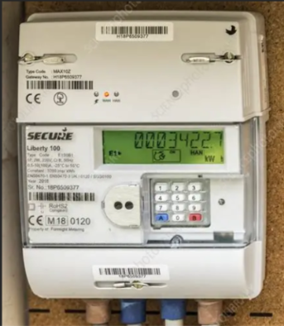
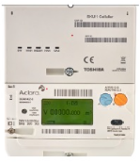

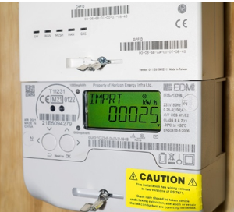
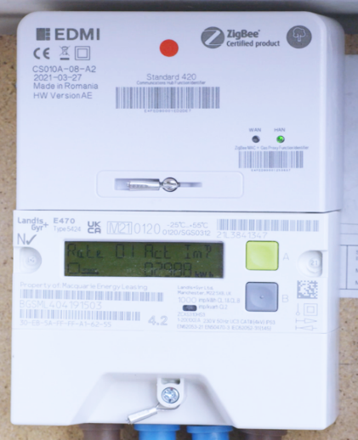

Return to homepage
FAQ
Accessibility Options
LOGO
Aclara Smart meter overview
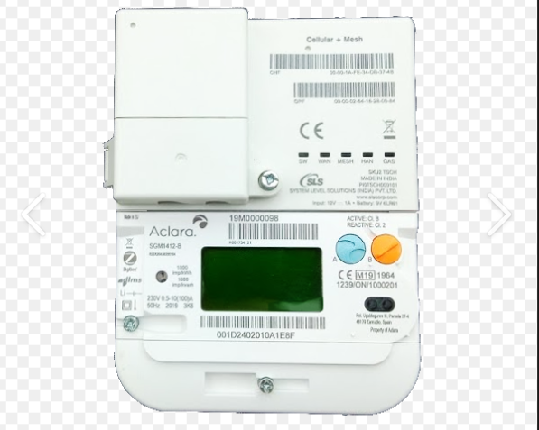
SW light shows the meters system is working correctly

WAN – Shows the meter can send readings to your energy supplier If this is off, the meter may not be sending readings automatically. Contact your supplier

Serial Number
MESH – helps the meter connect if a direct signal is weak

HAN – The home network that lets the smart meter talk to the in-home display (IHD).
Green HAN – SMART meter is connected and working properly
Red HAN – connection problem
Blank / no light – no active connection shown, device off.

Electricity use light
This light flashes faster when more electricity is being used

Return to homepage
GAS meter connects to the smart meter network so gas readings can be sent along with readings
Buttons A and B are click on the button which will open a box / pop up (see next page )

X
X

Button B screen order
- Confirms actions (Used when the meter tells you “Press B to continue”)

- Clears messages (If the meter shows a warning or alert, B removes it)

- Turns on Emergency Credit (PAYG only) (If you run low on credit, the meter may offer emergency credit — B accepts it)

- Reconnects your electricity (PAYG only) (If your power goes off because of no credit, B restores supply once allowed)

- Accepts Friendly Credit (PAYG only) (If the meter offers it, B confirms)

- Shows extra technical info (Pressing B can display things like meter serial number or signal status — read-only)
- Does nothing unless the meter asks (Button B only works when the screen specifically tells you to press it)

- Cannot change settings or readings (Safe to press — it won’t break anything or alter your bill)

The process of the buttons
Button A screen order
Button A – Scroll / Wake / Backlight
Press A – Screen wakes up
Press A - Import KWH – Total import used
Press A – Export KWH – only appears if you have PV solar or export tariff.
Press A – Rate 1 – Daytime (same as total if no other rates) (single rate tariff)
Press A – Rate 2 (if have) Nighttime / Off Peak rate
Press A – Rate 3 (if have / rare)
(More than one rate is Economy 7)
Press A Tarif price – EG- 0.29 GBP/KWH
Press A Standing charge - EG – 0.53 GBP / per day
- Supply status – shows whether your electricity supply is on

- Message Alerts –
After 60 seconds of inactivity, the meter goes dark and into standby

Accessibility Options
Smart Meter Navigation

Go back to
Previous page

Select your IHD device
Accessibility Options
LOGO
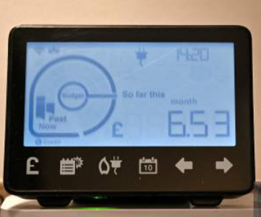
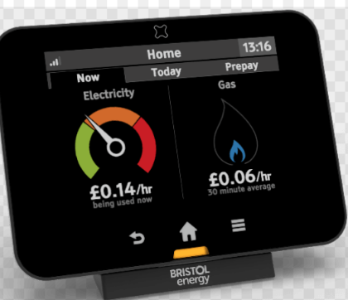
Example - user selects this image then see next page

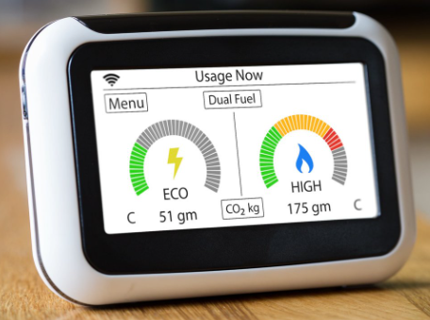
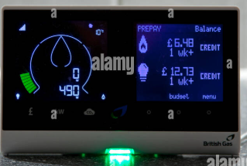

LOGO
IHD device overview for
Chameleon IDH3
Accessibility Options

Signal strength icon – shows the connection between IHD and smart meter
Electricity icon – shows you are viewing electricity usage

Usage gauge (Circular dial) – shows how much electricity you are using right now

Time display – current time

Monthly cost – your electricity cost so for this month
Now – current usage – updates in real time.

Past – recent usage – helps you compare spikes
Move between screens one at a time. Use these if you prefer simple scrolling.
Also all the icons along the bottom are clickable and take you straight to screen you want.
Return to homepage
Switch to gas view (only if gas meter paired)
Cost screens – daily, weekly, monthly cost

Date – todays date
Calendar – shows your usage trends overtime
Background colour ideas – Light Shade

Design Annotations

- Accessibility Options - Enhances usability for diverse users.

- Smart Meter selection grid - Reduces decision complexity through visual grouping.

- Help button - Provides recovery from error, aligning with Nielsen’s usability heuristics.

- FAQ – Further guidance, know they are not alone

